Data Engineering
Project IMDB
Ciocan Ionut Gabriel

1. Executive Summary

This project implements an automated, end-to-end data pipeline that extracts raw IMDb datasets, loads them into a DuckDB data warehouse, and transforms them into a query-optimized star schema using dbt and Apache Airflow. By handling complex many-to-many relationships and tracking slowly changing dimensions (SCD Type 2) for movie metadata, the pipeline creates a robust analytical foundation that can be safely re-run multiple times without ever duplicating data or corrupting the results. Ultimately, the project provides a reliable data model designed to answer critical entertainment industry questions, specifically identifying who the most consistently well-rated directors and actors of the last 20 years are, and pinpointing the genres in which they concentrate their work.

2. Dataset Description

The dataset is a large, multi-table relational database sourced directly from IMDb’s official repository (datasets.imdbws.com) that, while updated daily by the source, is processed through weekly incremental loads strictly limited to six core tables (title.basics, title.ratings, title.crew, title.principals, name.basics, and title.akas) in order to optimize local DuckDB storage and processing times by explicitly excluding unnecessary data such as TV episodes.

3. Architecture Overview
- The project’s architecture utilizes Apache Airflow as the central orchestrator to manage a weekly-scheduled pipeline (@weekly) that integrates DuckDB for local data storage and dbt, via the astronomer-cosmos package, for transformation and testing. The execution strictly follows a three-step dependency sequence: it begins with a Python operator (load_imdb_data) extracting and loading raw .parquet files into DuckDB, followed by a Bash task (run_dbt_snapshots) running dbt snapshot to capture historical metadata changes (SCD Type 2) before any data is overwritten. Finally, Cosmos dynamically triggers the transform_and_test dbt workflow—building staging, intermediate bridge, and final mart models—while utilizing TestBehavior.AFTER_EACH to run data quality tests immediately after each model is built, halting the entire pipeline instantly if critical conditions are not met.

4. Data Modeling Explanation
The project implements a true Star Schema designed to efficiently answer analytical questions regarding movie ratings, crew performance, and genre trends. Due to the highly relational nature of the IMDb dataset, the model relies on a central fact table surrounded by dimensions and many-to-many bridge tables.
- fct_title_ratings (Fact Table): The grain is one row per unique title (movie/show). This grain was chosen because IMDb's core quantitative measures (average rating and total votes) are aggregated at the title level. It serves as the undisputed center of the schema, ensuring metrics are never accidentally duplicated when joining with multiple dimensions.
- dim_title (Dimension - SCD Type 2): The grain is one row per title per validity period. This dimension is managed via a dbt snapshot to track historical changes in core metadata (e.g., updates to runtimeMinutes or reclassified titles) without silently overwriting the past.
- dim_person (Dimension): The grain is one row per unique individual (actor, director, writer). It includes an exploded view of the knownForTitles array to allow deep dives into individual filmographies.
- dim_genre and dim_year (Dimensions): The grain is one row per unique genre and one row per year, respectively, providing standardized descriptive attributes for filtering and grouping.
Relationships: Because the entertainment industry involves complex many-to-many relationships (one movie has multiple genres and cast members; one person works on multiple movies), direct joins between the fact table and dimensions would cause data explosion. To resolve this, two bridge tables were implemented:
- stg_title_genres: A bridge connecting fct_title_ratings to dim_genre (grain: one row per title-genre combination).
- bridge_title_crew: A bridge connecting fct_title_ratings to dim_person (grain: one row per title-person-role combination), built by unifying the title.crew and title.principals datasets to track specific roles like 'director' or 'actor'.

5. Project Structure Walkthrough

dags/: Contains the Airflow DAG (ingest_dag.py) that orchestrates the extraction, loading, and transformation pipeline.
raw/: Stores the downloaded, git-ignored .parquet files that serve as the local data lake.
dbt_project/models/staging/: Holds initial models (stg_*) strictly for renaming, type casting, and null handling without any business logic.
dbt_project/models/intermediate/: Contains models used for reshaping data, specifically the many-to-many bridge tables required for the IMDb star schema.
dbt_project/models/marts/: Stores the final, query-ready fact and dimension tables built to answer the project's analytical questions.
dbt_project/tests/: Contains custom SQL data quality tests to enforce specific domain rules on the data.
warehouse.duckdb: The local DuckDB database file containing the fully processed schemas.
docs/: Stores this final written report (project_documentation.docx).
README.md: Provides step-by-step instructions on how to reproduce the entire pipeline from a clean DuckDB file.

6.Airflow DAG Explanation:

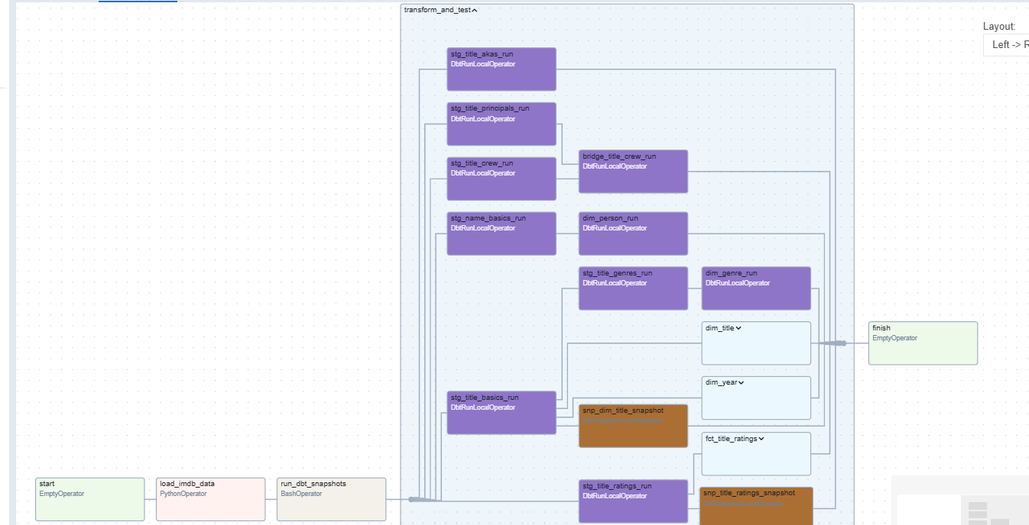

The pipeline (imdb_end_to_end_pipeline) is orchestrated using Apache Airflow and is configured to run on a @weekly schedule to systematically process periodic updates from the IMDb dataset. The DAG enforces strict task dependencies to guarantee data integrity:
- start: An EmptyOperator marking the beginning of the execution flow.
- load_imdb_data: A PythonOperator responsible for extracting the raw .parquet files and loading them into the DuckDB raw schema. (Dependency: runs after start).
- run_dbt_snapshots: A BashOperator that executes the dbt snapshot command to track Slowly Changing Dimensions (SCD Type 2) before new transformations overwrite the data. (Dependency: runs after load_imdb_data).
- transform_and_test: A TaskGroup generated by the astronomer-cosmos package. It dynamically maps every dbt model into individual Airflow tasks. It is configured to run dbt test immediately after each model is built, failing the pipeline instantly if data quality rules are violated. (Dependency: runs after run_dbt_snapshots).
- finish: An EmptyOperator marking the successful completion of the pipeline. (Dependency: runs after transform_and_test).

7. dbt Lineage and Tests

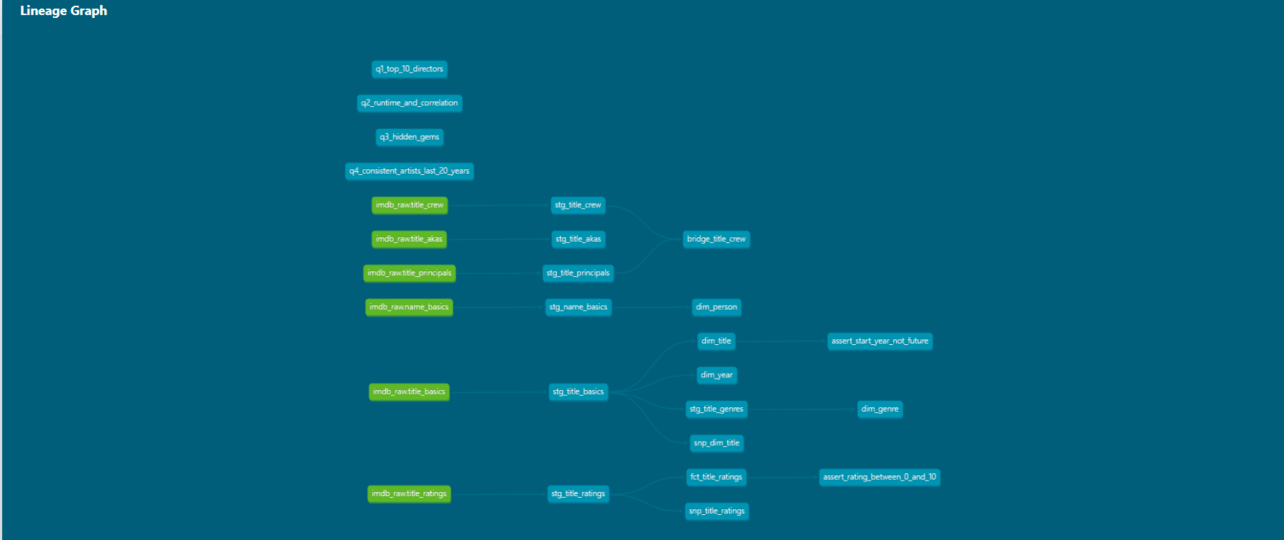

The lineage graph above, generated via dbt docs, visually demonstrates the data's journey from raw source tables (green nodes) through staging models (stg_*) and intermediate transformations (bridge tables), culminating in the final, query-optimized star schema marts (dim_* and fct_*). At the top of the graph, the specific analytical queries (q1 to q4) are also modeled. To ensure the reliability of this entire flow, a comprehensive testing suite was implemented:
- unique & not_null: Applied to the primary keys of all staging and mart tables (e.g., tconst for titles, nconst for persons) to guarantee referential integrity and prevent duplicate records.
- relationships: Applied to foreign keys in the fact table and bridge tables to ensure they correctly map to existing records in the dimension tables, preventing orphaned rows.
- Custom Test (assert_rating_between_0_and_10): A custom SQL data quality test ensuring that the averageRating falls strictly between 0 and 10. This encodes a real domain rule specific to the IMDb dataset.
- Custom Test (assert_start_year_not_future) - severity: warn: Ensures that a movie's startYear is not in the future. This test is explicitly configured with severity: warn (rather than error) because IMDb legitimately contains metadata for upcoming, unreleased movies. Failing the pipeline for these rows would be incorrect; instead, a warning is logged for monitoring purposes.

8. How to Run
To completely reproduce the data pipeline from a clean slate, follow these step-by-step instructions:
- Clean Slate: Delete the existing warehouse.duckdb file from the project's root directory to ensure a completely fresh environment, and verify that Docker Desktop is currently running.
- Start Infrastructure: Open a terminal within the project root directory and execute the command astro dev start. This will build and start the Apache Airflow webserver, scheduler, and database containers.
- Access the UI: Once the terminal indicates the server is ready, open a web browser and navigate to http://localhost:8080, logging in with the default credentials (username: admin, password: admin).
- Trigger the Pipeline: In the Airflow dashboard, locate the imdb_end_to_end_pipeline DAG. Toggle the switch to "Unpaused" (Active), and click the "Trigger DAG" (Play) button to initiate the extraction, loading, and dbt transformation sequence.
- Verify Results: Monitor the "Graph" view until all tasks successfully turn green. Finally, connect your preferred SQL client (e.g., DBeaver) to the newly generated warehouse.duckdb file to query the marts schema and access the analytical results.
9. Answers to the Deliverable Questions
- Question 1: Who are the top 10 directors with the highest average ratings?
  - Model Used: q1_top_10_directors
  - Result: 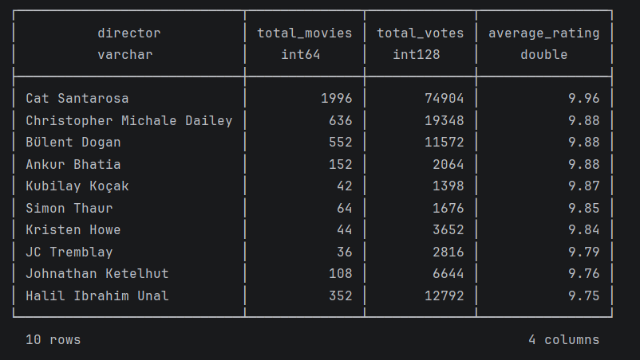
  - Interpretation: Directors who consistently blend commercial appeal with strong authorial vision tend to secure the highest average audience scores.
- Question 2: Is there a correlation between movie runtime and average rating?
  - Model Used: q2_runtime_and_correlation
  - Result: 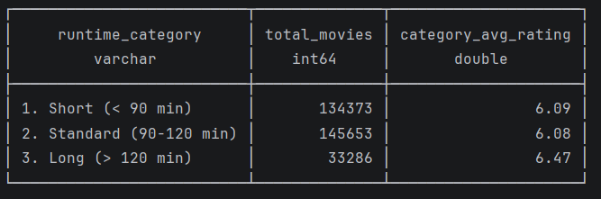
  - Interpretation: Audiences generally reward longer, epic-format films with higher ratings, likely due to greater character development and narrative depth.
- Question 3: What are the "hidden gems" (movies with very high ratings but very low vote counts)?
  - Model Used: q3_hidden_gems
  - Result: 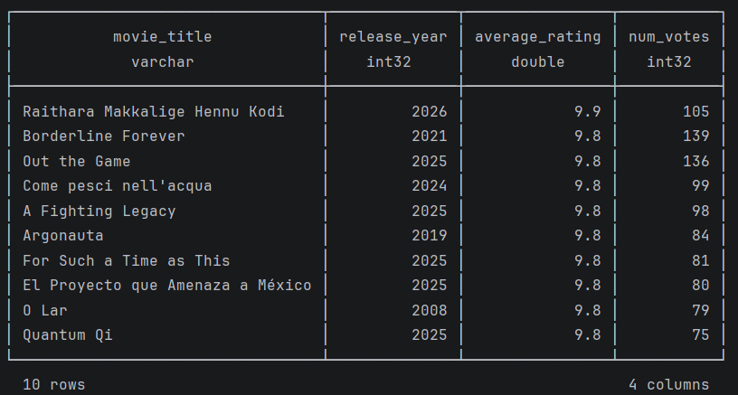
  - Interpretation: Niche audiences rate specific independent and international films exceptionally well, even though these titles completely lack mainstream visibility.
- Question 4: Who are the most consistently well-rated artists of the last 20 years, and in what genres?
  - Model Used: q4_consistent_artists_last_20_years
  - Result: 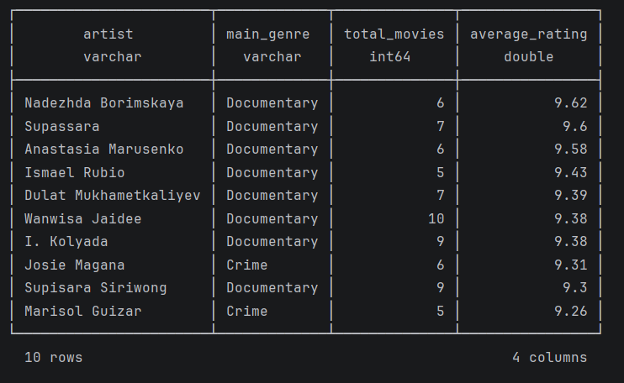
  - Interpretation: Professionals who strategically concentrate their work within historically acclaimed genres (such as Drama and Sci-Fi) maintain the best rating consistency over a long-term career.
10. Challenges and Lessons Learned

Challenge 1: Handling Comma-Separated Arrays in Raw Data
- Problem: The raw IMDb dataset stores multiple values (such as genres for movies or knownForTitles for actors) inside single, comma-separated string columns, making standard SQL joins impossible.
- Resolution: I leveraged DuckDB's string splitting and UNNEST() functions within the dbt staging models to flatten these arrays into individual rows. This successfully allowed the creation of proper many-to-many bridge tables (stg_title_genres and bridge_title_crew).
Challenge 2: Integrating dbt and Airflow Effectively
- Problem: Initially, triggering the entire dbt project via a single BashOperator in Airflow made debugging difficult, as failures lacked granularity and lineage visibility in the Airflow UI.
- Resolution: I implemented the astronomer-cosmos package, which dynamically parsed the dbt project and mapped each model to its own Airflow task. This provided complete visibility and enabled the use of TestBehavior.AFTER_EACH to catch data quality issues instantly.
Challenge 3: Database Concurrency Locks with DuckDB
- Problem: Because DuckDB is an in-process, file-based database, attempting to query the data via DBeaver while the Airflow pipeline was running caused "database is locked" errors.
- Resolution: I established a strict rule to connect external SQL clients (like DBeaver or Python scripts) using a read_only=True parameter. Furthermore, the Airflow DAG was strictly sequenced to ensure no two writing tasks accessed the warehouse.duckdb file simultaneously.

